GOTHIC

The development of the Gothic spirit in the late Romanesque period was a result of the change and development of European society from the eighth through the eleventh century, and of the final renaissance and reconstitution of the culture following the ending of Roman influence in Europe and the assimilation of eastern invaders into the society.
The establishment of the kingdom of France by Hugh Capet in 987 A.D. initiated a process of checking the power of the feudal barons over the people. Combined with the growth of independent cities, this caused a change in the structure of society which added impetus to the development and crystallization of its institutions and conceptual patterns. By the eleventh century feudalism had become general, with order and stability established over much of Europe, while the growth of the power of kings acted as a control upon the power of the barons. Society was organized upon the basis of sovereignty and personal loyalty and obligations, based upon the Christian ethic. Secular government was centered on small local political spheres,
as the low technological level and difficulty of communication hindered centralization.While the political power remained in the hands of local barons, the power of the church,
centered in Rome, grew, establishing uniformity of doctrine and giving impetus to the development of a common religious, philosophical and moral system throughout Europe. During the Romanesque period man recognized the concept of God as the highest power,unapproachable and judging, while in the Gothic period he thought more in terms of the approachability and love of God, and his closeness to man through Christ and his suffering. This change appears and is expressed in the cathedrals in the change from a frontality and formality of the parts to an obliqueness, as in the arrangement of pier clusters; a change from independent
special units to a unification of the space
The Seven Key Characteristics of Gothic Architecture:
Fundamentally, gothic architecture transformed castles, churches, cathedrals and pretty much the whole of Europe.This style of architecture developed because of common architectural problems in Medieval times. Back in the 1100s-1200s, building skills were extremely limited. Stone castles were rudimentary - dark, cold, and damp. Gothic architecture tried to solve some of these unpleasant problems, and created light, pleasant and airy buildings.
Some gothic buildings - particularly churches and cathedrals, such as York Minster, in York, England (the largest gothic cathedral in Northern Europe) - were rendered into awe-inspiring places of piety and worship, as a result of their phenomenal gothic design.
Many castles adopted some of the characteristics of gothic architecture, too. They became transformed from dank living environments into majestic, light and pleasant residences for the lords and ladies within.
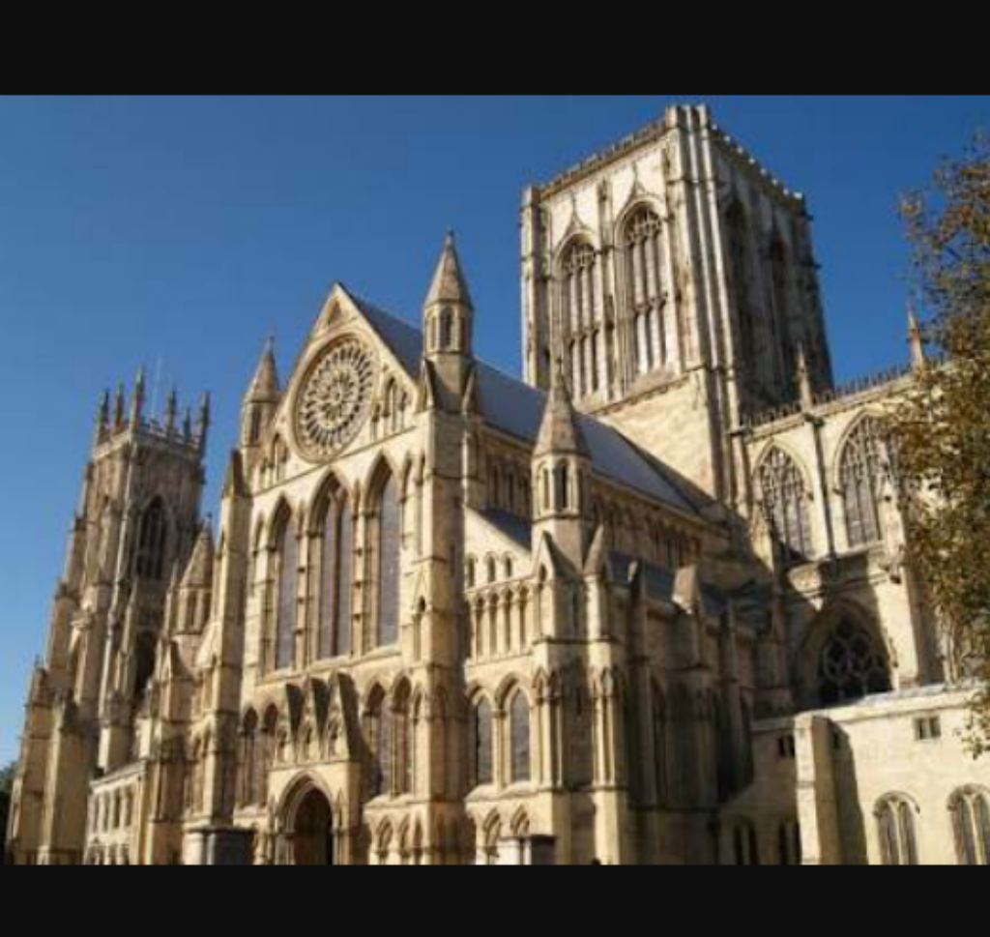

The cathedral pictured above is York Minster
In the times before gothic architecture, Early Medieval architects struggled to spread the weight of heavy stone walls.This meant that most towers needed to be short, and buildings thin, otherwise the sheer weight of higher levels (or large rooms and halls) would collapse into themselves.One of the fundamental characteristics of gothic architecture was its height. New building techniques (such as the flying buttress) enabled architects to spread the weight of taller walls and loftier towers.This all meant that gothic buildings could, quite literally, scale new heights. It allowed them to reach up to the heavens - perfect for cathedrals and churches.

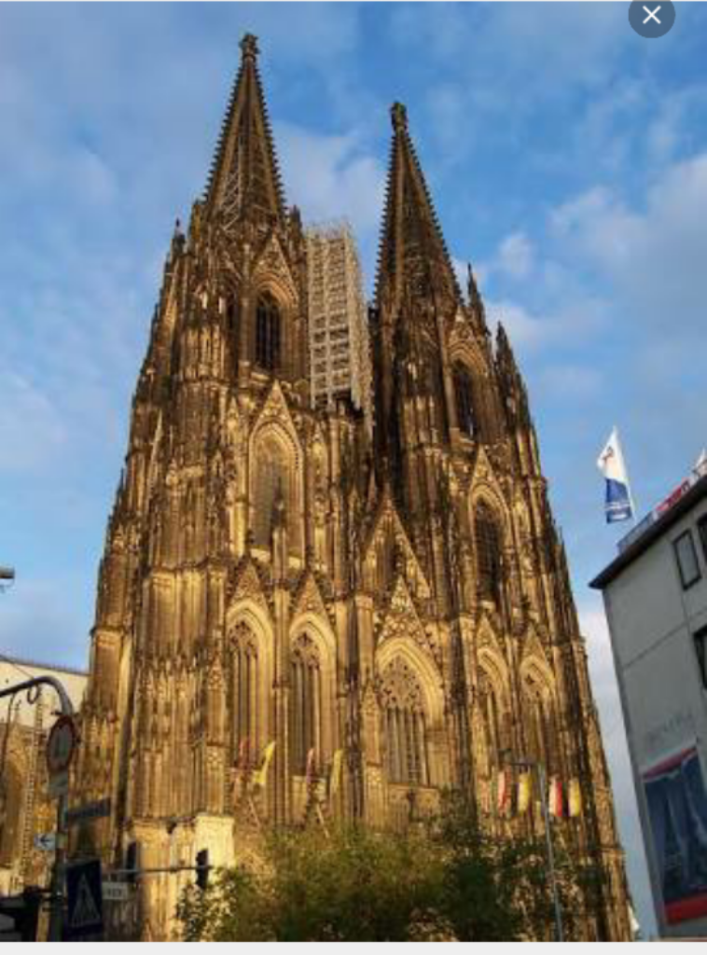
This is the famous Dom - or cathedral - of Cologne.

It's one of the most visited tourist attractions in Germany, and miraculously survived the bombings of World War II. It's a phenomenal example of gothic architecture, exhibiting all seven characteristics of this amazing design style.
2. The Flying Buttress
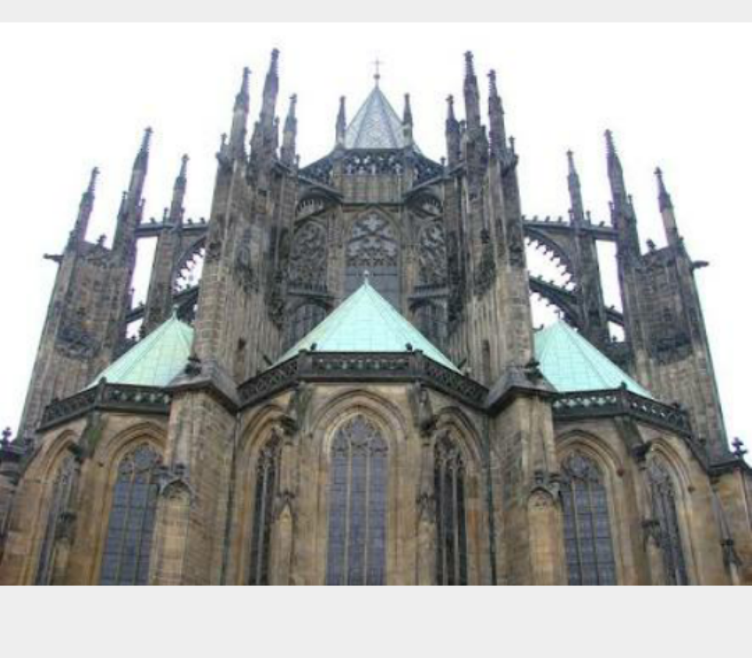

St Vitus Cathedral in Prague Castle.

The flying buttress is the defining external characteristic of gothic architecture.A new technological development - the flying buttress - meant that it was possible to build taller, wider and grander buildings. The flying buttress took the strain of the thicker walls, and made ambitious designs possible. These buttresses effectively spread the weight of the new designs, taking the weight off the walls and transferring force directly to the ground.The flying buttress was practical and decorative, too. Rather than just being a simple support, buttresses were often elaborately designed and extremely decorative. They appeared to dart and sweep around each building, giving a sense of movement and of grandeur missing from previous architectural designs.

3. The Pointed Arch
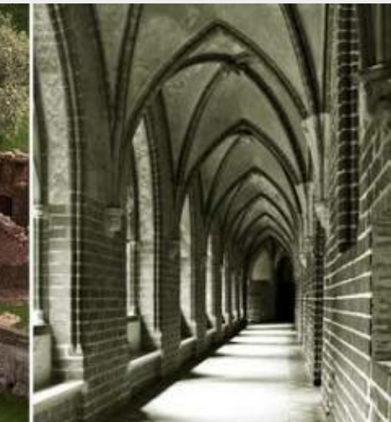

Malbork Castle, in Poland,
The innovation of the pointed arch which was the defining internal characteristic of gothic architecture. Its significance was both practical and decorative. The pointed arch effectively distributed the force of heavier ceilings and bulkier designs, and could support much more weight than previous, simple pillars.The stronger arches allowed for much more vertical height, too - they literally reached up to the heavens. The gothic arch wasn't just a workhorse. It had an aesthetic value and beauty which influenced many other features of gothic design - most notably the vaulted ceiling.So, rather than having massive, drum-like columns as in the Romanesque churches, the new columns could be more slender. This slimness was repeated in the upper levels of the nave, so that the gallery and clerestory would not seem to overpower the lower arcade. In fact, the column basically continued all the way to the roof, and became part of the vault.

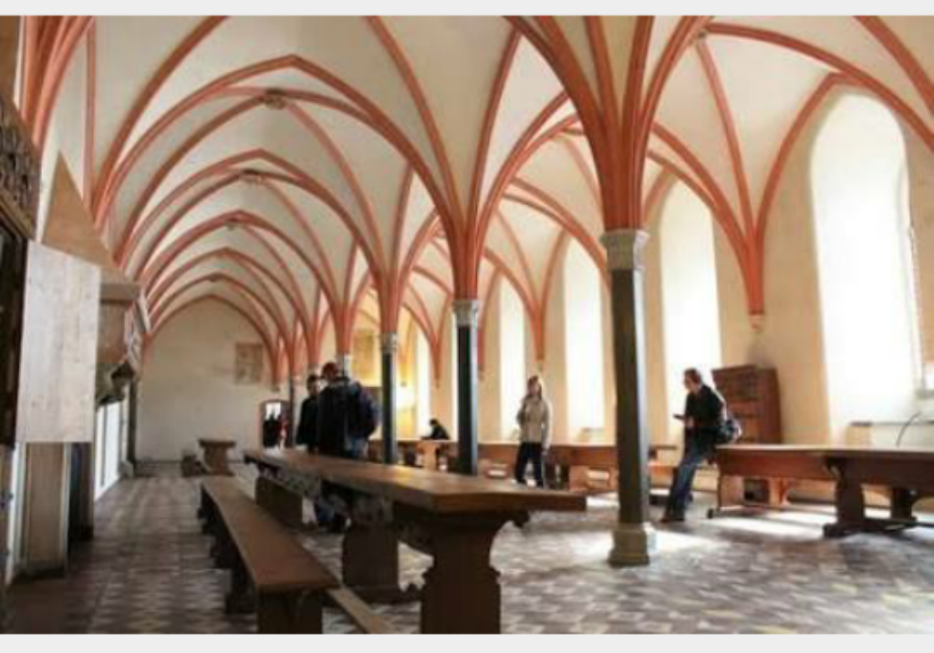

4. The Vaulted Ceiling
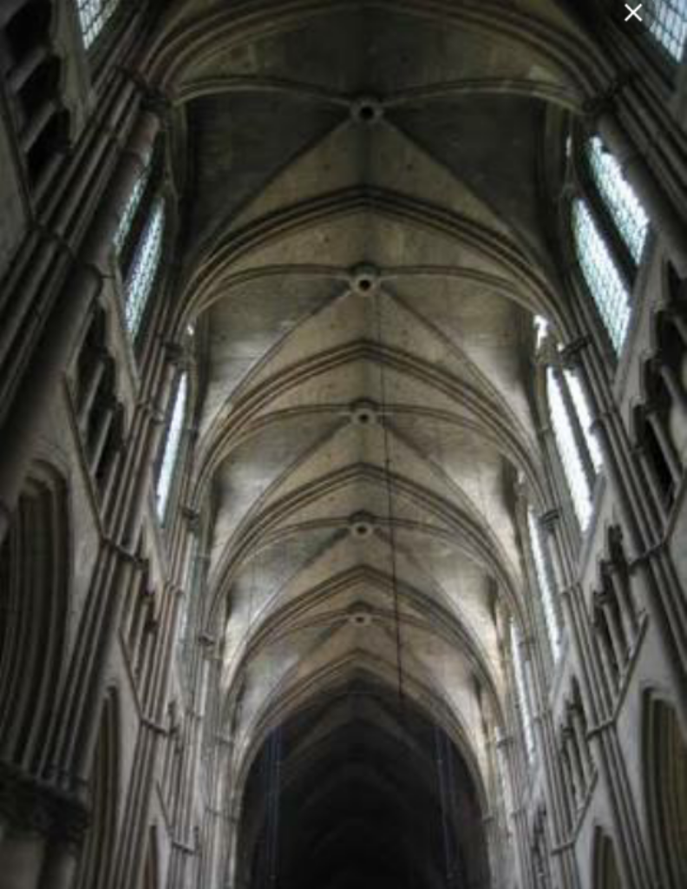
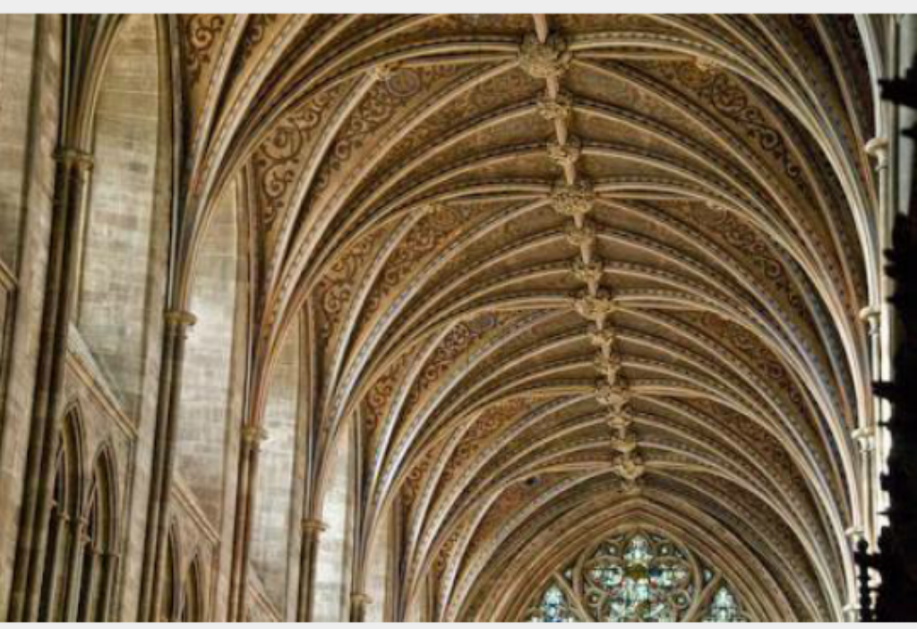

The vaulted ceiling was an innovation which lead on from the achievements of the pointed arch. The ceilings in gothic buildings were made of up grand, pointed arches, which created an interesting, vaulted effect. These vaults often gave the impression of height and majesty. They contrasted dramatically to the short and dark towers of older castles. The ribbed vaulting became more complicated and was crossed with lierneribs into complex webs, or the addition of cross ribs, called tierceron. As the decoration developed further, the Perpendicular or International Gothic took over (fifteenth century). Fan vaulting decorated half-conoid shapes extending from the tops of the columnar ribs
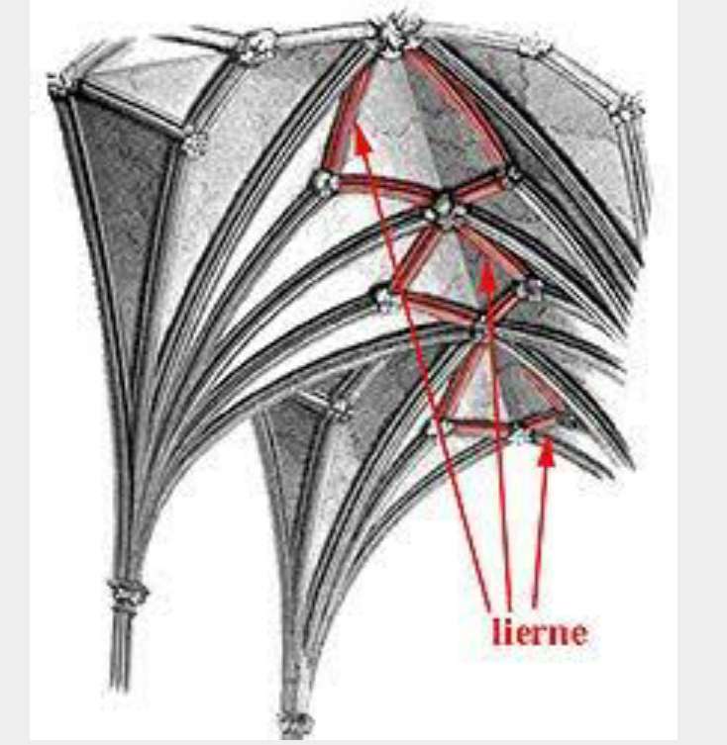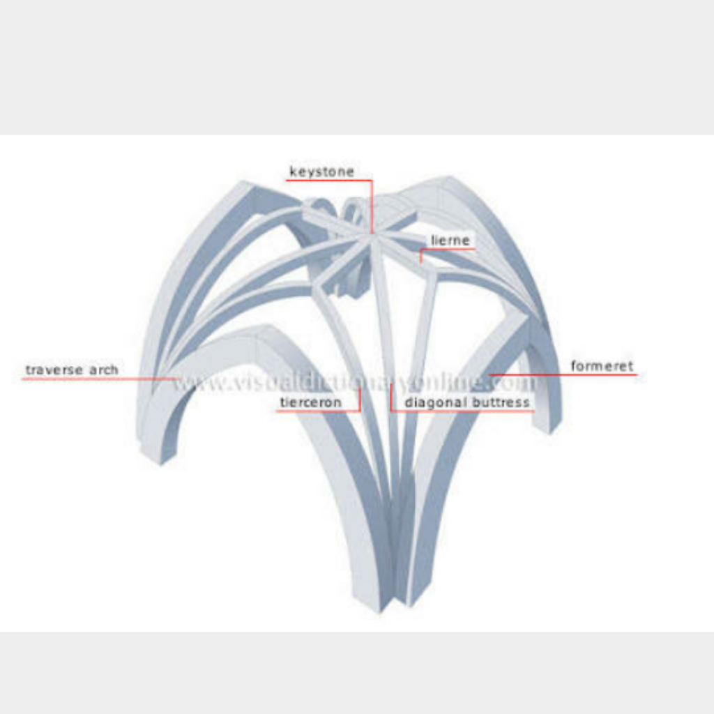
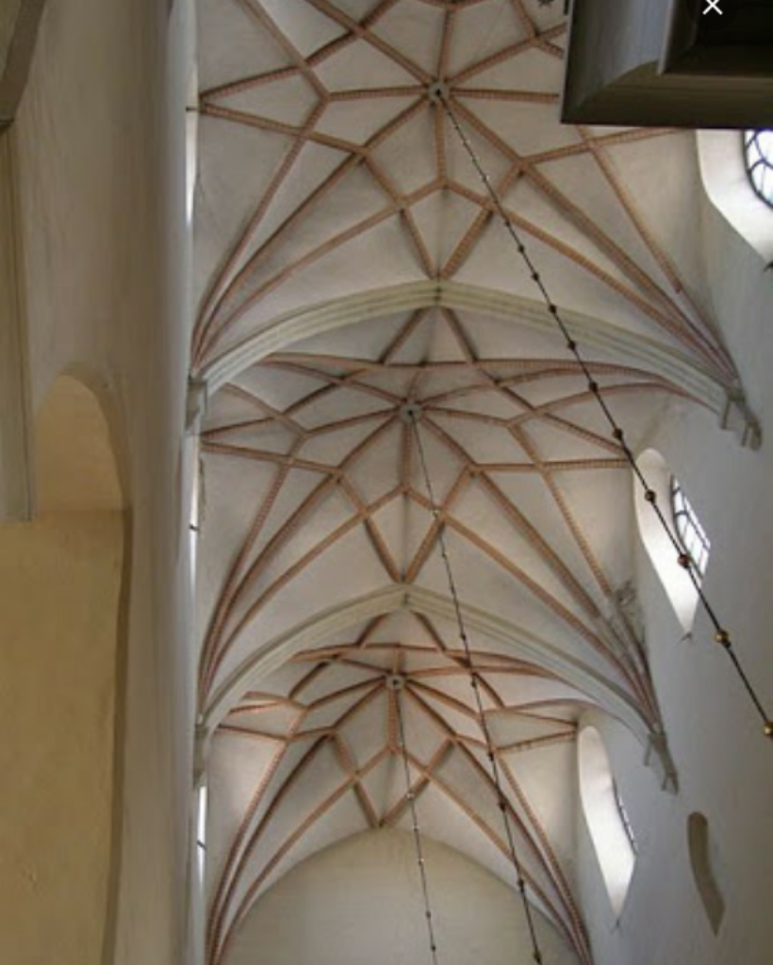
The slender columns and lighter systems of thrust allowed for larger windows and more light. The windows, tracery, carvings, and ribs make up a dizzying display of decoration that one encounters in a Gothic church. In late Gothic buildings, almost every surface is decorated. Although such a building as a whole is ordered and coherent, the profusion of shapes and patterns can make a sense of order difficult to discern at first glance.

5.The Light and Airy Interior
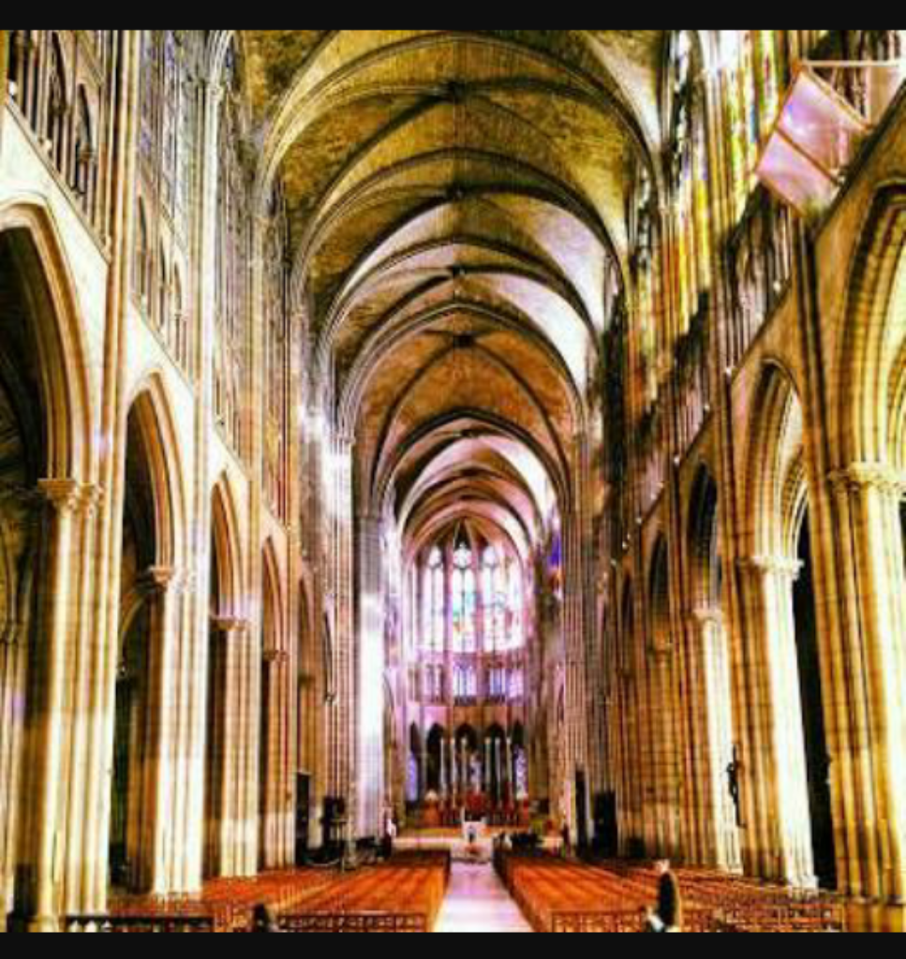
Before gothic architecture, castles and early Medieval buildings were pretty depressing places to live in or worship in. Castles, in particular, were places of damp and mould, as most weren't built strong enough to support slate or stone roofing. Although these fortresses could more or lesprop up wooden roofs, these let in the rain.If that wasn't depressing enough, these old environments tended to be dark and dingy. The windows were generally tiny, as the force of the walls would collapse into themselves if they included any larger glassworks.Gothic architecture strove to be the exact anthesis to this older Medieval style of building.It emphasised light, bright windows and airy interiors, transforming castles and churches into more pleasant and majestic environments.
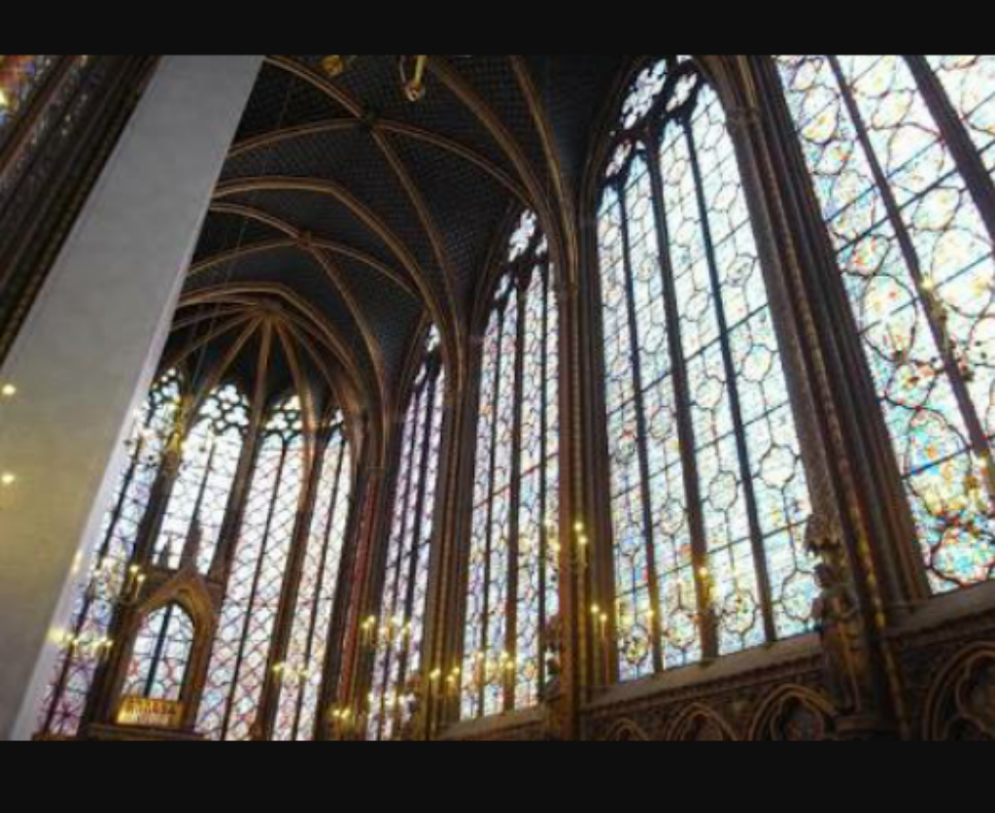
6. The Gargoyles of Gothic Architecture
4 A classic gargoyle - you can see his dual purpose as a decoration and also as a water-spout.
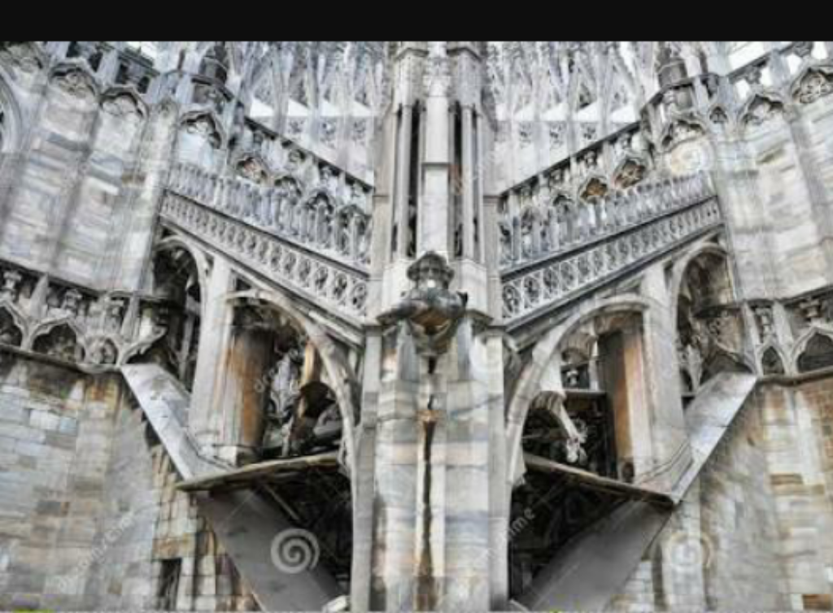

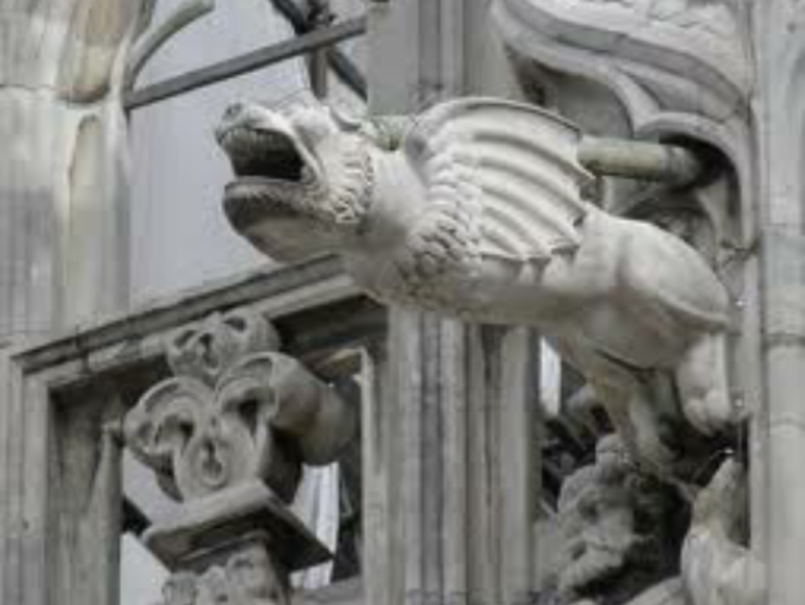
One of the most notable characteristics of gothic architecture is the gargoyle. Gargoyles are decorative, monstrous little creatures, perched at along the roofs and battlements of gothic buildings and castles.
Gargoyles have a practical purpose: they're spouts, enabling rainwater to drain off the roof and gush through their mouths, before plummeting to the ground.However, gargoyles had another intended purpose: to strike fear into the hearts of ill-educated Medieval peasants, scaring them into the church or cathedral. Many gargoyles include elements of the grotesque: exaggerated, evil features or threatening poses, which would have leered down from on-high.In a world marked with fear and superstition, these creepy creatures would undoubtedly have encouraged many to seek solace and safety inside of a church or cathedral- protected from the demons and ghouls which roamed outside. The gargoyle is one of the defining characteristics of gothic architecture.
7. The Emphasis Upon the Decorative Style and the Ornate
Gothic architecture marked the first time that beauty and aesthetic values had been incorporated into building design. This revolutionised the way that Medieval architects began to think of buildings. Architecture was no longer just functional - it began to have merit and meaning in its own right.The ornate stonework that held the windows–called tracery–became more florid, and other stonework even more exuberant.
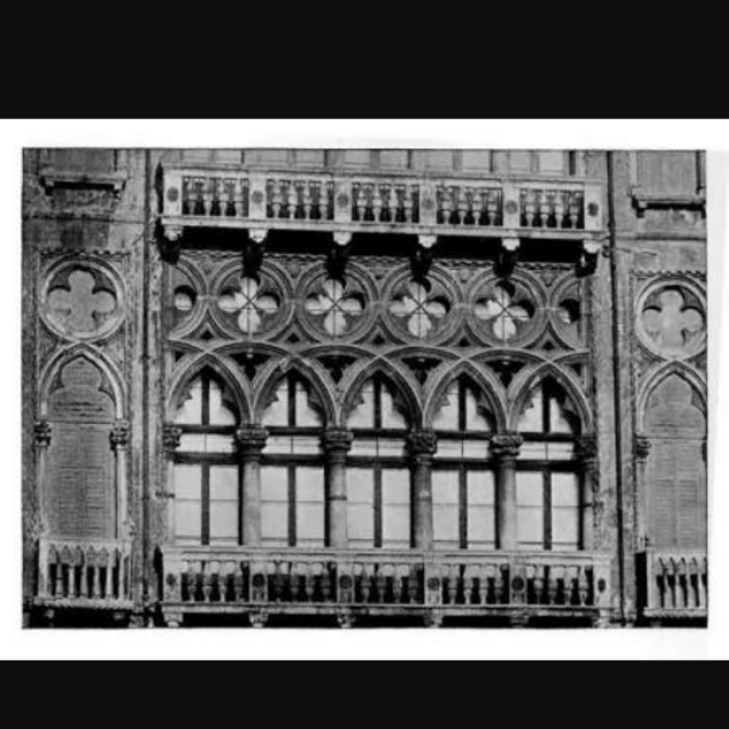
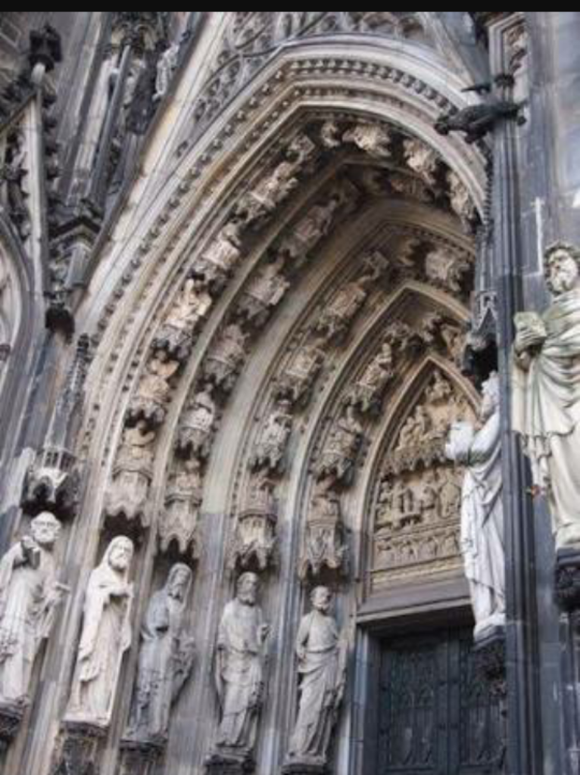
This doorway of Cologne Dom exemplifies the ornate, gothic style.
Increasingly ambitious and ornate designs of church, cathedral and castle came to be built. Rivalry and competition drew different groups of builders to conceive and construct grander and more decorative designs, for the glory of the Christian region.
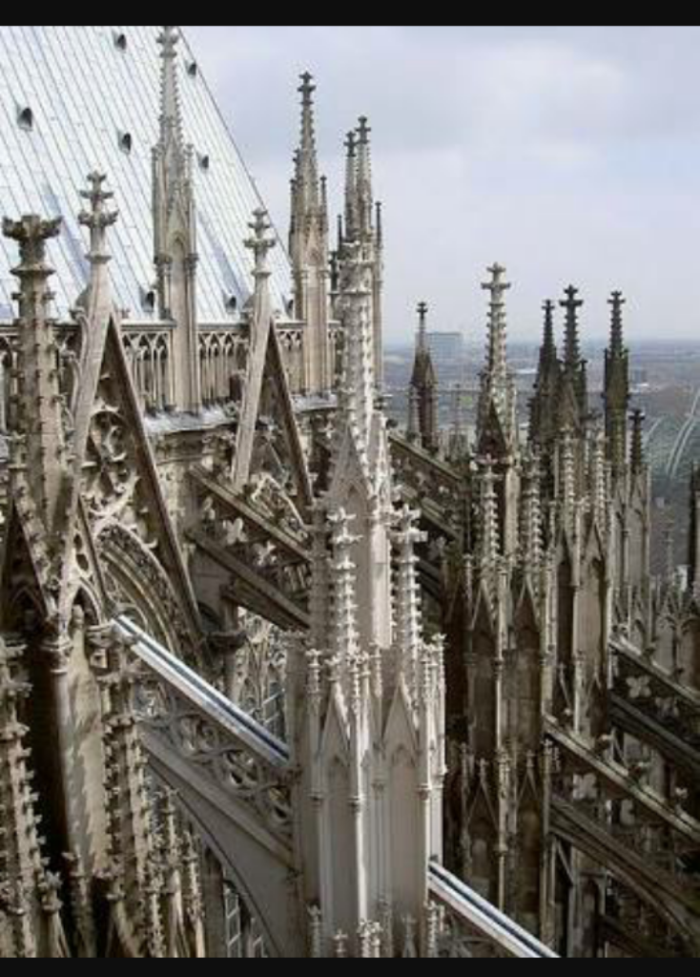
This tremendous spire of the Dom in Cologne, Germany, shows the reach, height, grandeur and intricate detail of the gothic style.

Hunyad Castle - Hidden In Transylvania
one of the spookiest of all gothic castles.

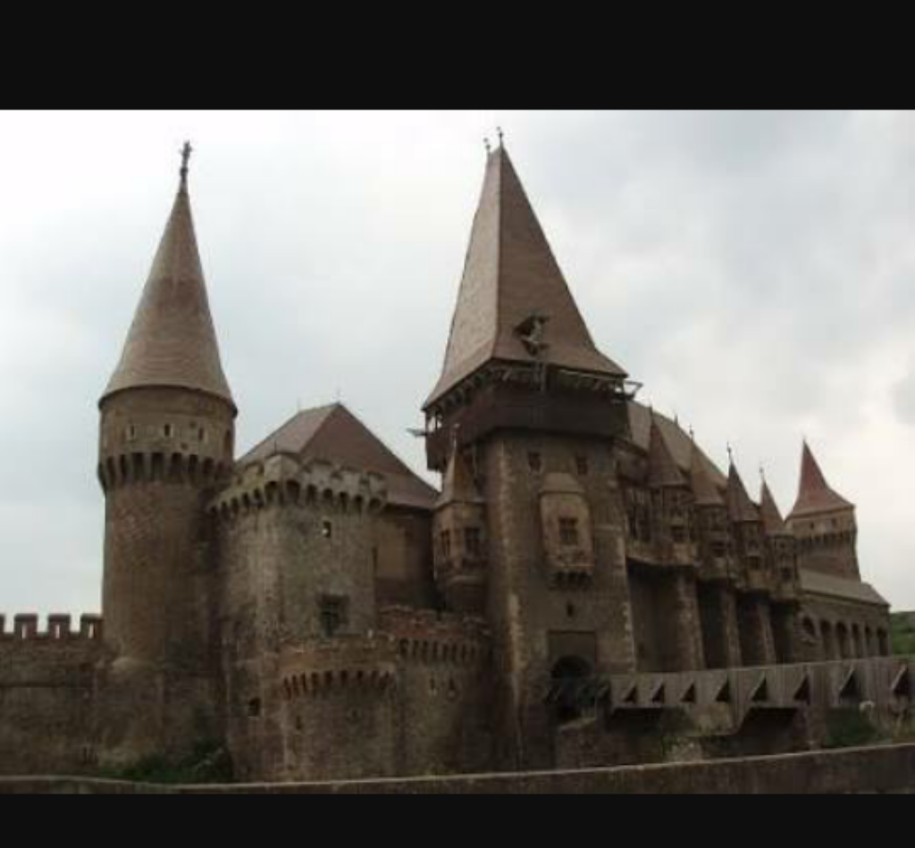
It's a perfect example of gothic architecture. It boasts a huge, threatening bulk, with witches-hat style turrets studded along its side. Parts of the castle exterior are decorated with over-ornate gothic detail (see the picture just below), and the innards are filled with vaulted-ceilings over vast, echoing halls. Hunyad Castle is located in Transylvania, Romania.
St. Stephen’s Cathedral. Vienna, Austria. 1137

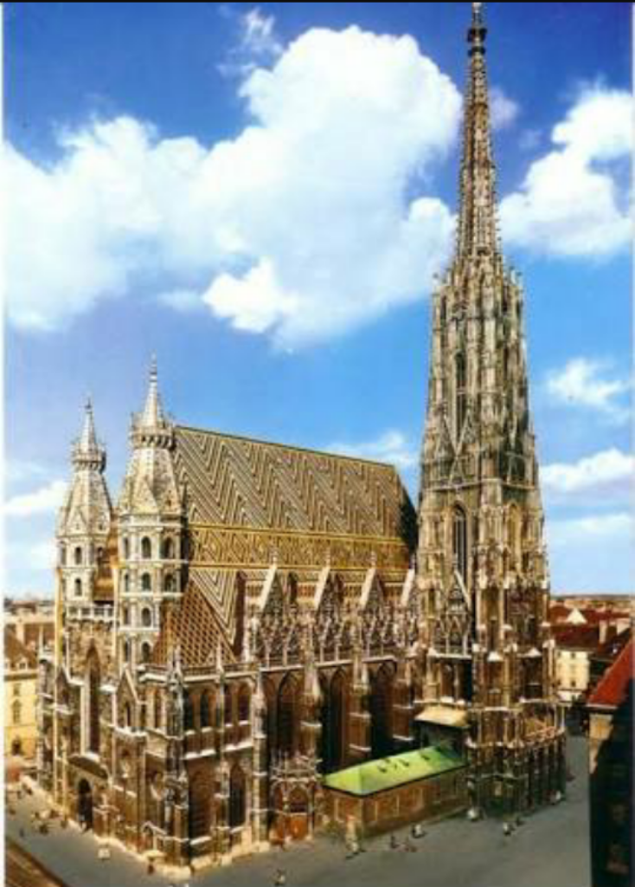

Considered as the most eminent Gothic edifice in the whole of Vienna, St. Stephen’s Cathedral is where most of Vienna’s art treasures lie. Its Gothic style is apparent in its pulpit, red marble sepulcher, and its Gothic-winged altar that was completed in 1447.

